Model-1 Plot

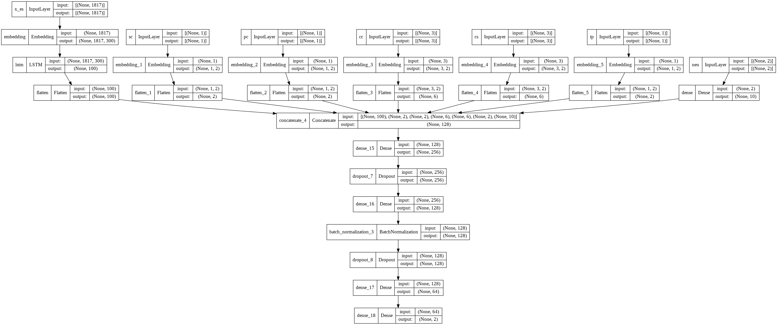

Model 1 Observations:

* Epoch Vs Accuracy

In the below image validation accuracy and train accuracy is plotted with respect to each epoch.

The best accuracy for validation data set is .8473 which is interestingly constant throughout the training epochs while for train it’s .8522 at 6th epoch. The minimum difference we can see at 9th epoch.

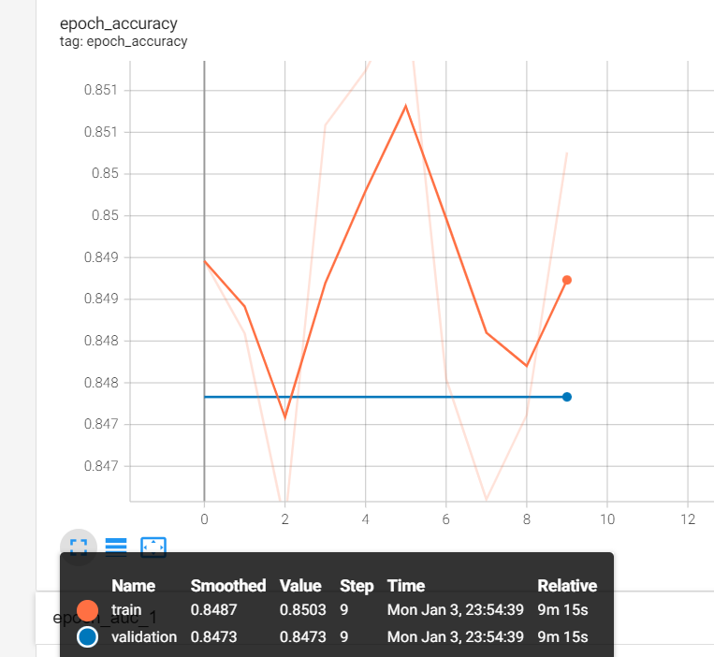

* Epoch Vs AUC Score

In the below image validation AUC and trainAUC is plotted with respect to each epoch.

Which we can see quite steady throughout all the epochs for both the train and validation data.

The best AUC for validation data set is .8782 at 9th epoch while for train it’s .8758 at 2nd epoch.

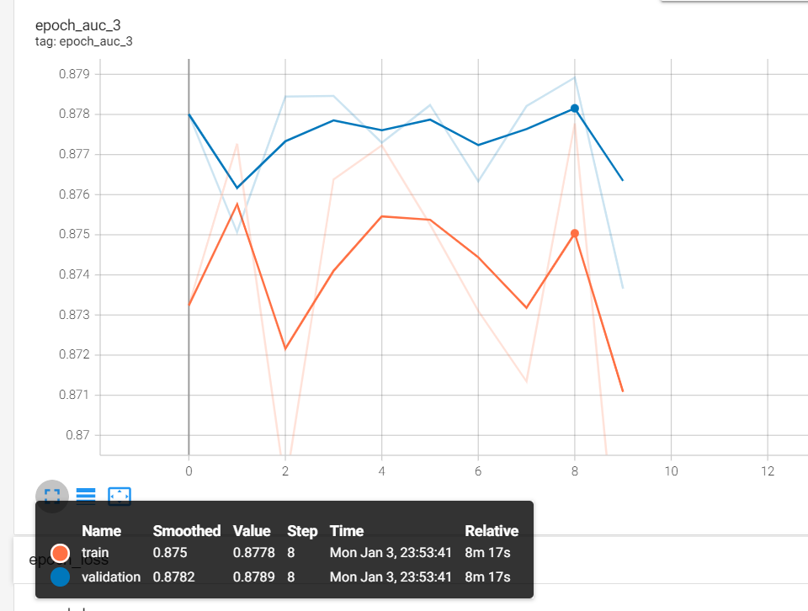

* Epoch Vs Learning Rate

We can see the learning rate to change after 3rd epoch as its designed to do so through call back.

* Epoch Vs Loss

In the below image validation loss and train loss is plotted with respect to each epoch.

Which we can see decreasing with each epoch for both the train and test data.

The loss for validation data set is .6932 at 5th epoch while for train it’s .6931 at 5th epoch.

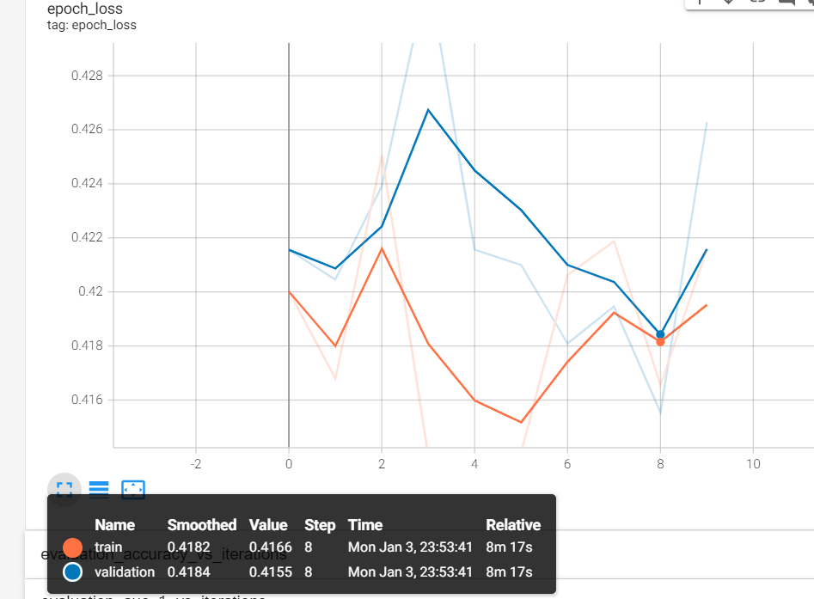

* Epoch Vs Loss

In the below image validation loss and train loss is plotted with respect to each epoch.

Which we can see for both train and validation data set loss value ranges between .4 to .42 which is quite good given such high AUC scores.

**\*Note:** We can see for the all the above plots the minimum difference between train and validation is occurred at 9th epoch. So weights calculated at 9th should be used for this model as a proper fit.